**VISVESVARAYA TECHNOLOGICAL UNIVERSITY**

**“JNANA SANGAMA”, BELAGAVI – 590 008**



**INTERNSHIP/PROFESSIONAL PRACTICE REPORT**

Submitted in Partial Fulfilment for the Award of Degree of

**Bachelor of Engineering**

in

**ELECTRONICS AND COMMUNICATION**

Submitted by

**PRAJWAL SAMPGAON**

**2KL16EC050**

Internship Carried Out at

**“Advanced Technology for Smarter & Secured life(ATSSL)Belagavi”**

|  |  |
| --- | --- |
| **Internal Guide** | **External Guide** |
| Name**:** Rudrappa Gujanatti | Name**:** Mr. SHIVANAND CHOUGALA |
| Designation: Professor | Designation: Technical Leader |
| College Name: K.L.E Dr. M. S. Sheshgiri College of Engineering and Technology | Organization name: Advanced Technology for Smarter & Secured life(ATSSL)Belagavi. |



**ELECTRONICS AND COMMUNICATION**

**KLE Dr. M. S. Sheshgiri College of Engineering and Technology.**

**2018-2019**

**KLE Dr. M.S. Sheshgiri College of Engineering and Technology**



**ELECTRONICS AND COMMUNICATION**

**CERTIFICATE**

This is to certify that the “**Internship/professional practice report”** submitted by **Mr. PRAJWAL SAMPGAON (2KL16EC050)** a bonafide student of K.L.E Dr. M.S. Sheshgiri College of Engineering and Technology, in partial fulfilment for the award of Bachelor of Engineering in Electronics and Communication of the Visvesvaraya Technological University, Belagavi, during the academic year 2019-20. It is certified that all corrections/suggestions indicated for Internal Assessment have been incorporated in the report, the report of the Internship/Professional practice has been approved as it satisfies the academic requirement in respect of Internship/ Professional practice for the said degree.

|  |  |
| --- | --- |
| **Signature of the Internal Guide** | **Signature of the Head of the Department** |
| **Name:** Rudrappa Gujanatti | **Name:** Dr. Rajashri Khanai |
| **Designation:** Professor | **Head of the Department** |

**EXTERNAL VIVA**

|  |  |
| --- | --- |
| **Name of the Examiner** | **Signature with date** |
| **1.** |  |
| **2.** |  |

**ACKNOWLEDGMENT**

I express my sincere gratitude to “Advanced Technology for smarter & Secure life(ATSSL)Belagavi” for giving me an opportunity to complete my two-month Internship during my 8th semester as part of my B.E-Electronics and Communication course.

I thank Dr. Rajashri Khanai, HOD-Electronics and Communication Department, of K.L.E Dr. M. S. Sheshgiri College of Engineering and Technology, Belagavi, Karnataka who has encouraged me to undergo an Internship.

I thank my internal guide Prof. Rudrappa Gujanatti, Electronics and Communication Department, K.L.E Dr. M. S. Sheshgiri College of Engineering and Technology for supporting and guiding me in this course.

I also thank Mr. Shivanand Chougla, , “Advanced Technology for Smarter & Secure life(ATTSL). Belagavi” for his consent as my guide during my internship and for his support, motivation and his valuable guidance to successfully complete my internship and to carry out the assigned project.

Last but not the least I would like to thank all the staff members of “Advanced Technology for Smarter & Secure life(ATSSL). Belagavi” to directly or in-directly help me during my internship.

**EXECUTIVE SUMMARY**

This is an internship report, undertaken by Mr. Shivanand Chougla at “Advanced Technology for Smarter & Secure life(ATSSL)” –Belagavi. The intern started her internship from 10th January to 10th February , 2020. In fulfilment of the requirement of the Degree, it is mandatory for students to have a minimum of one (1) month practical industrial experience in their respective fields of training and organisation of their choice. An Industrial attachment is essential requirement for awarding of Bachelor Degree Certificate in the VTU. The purposes of the internship is to prepare the student to serve the needs of industry and commerce more effectively upon graduation. This included providing real life experience and exposure, thus gaining first-hand exposure of working in the real world, granting the opportunity to learn more about the intern self-potentials and abilities, getting connected and developing professional network, preventing CV from going to trash during job application and transition to full-time job position. Internship allows students to harness the skill, knowledge and theoretical practice they learnt in the University and enabling them to transform theory into practical real life situations. The intern’s time with Mistral Solutions private Limited has really illuminated his knowledge and understanding of practical experience of the theories being taught between the walls of the University lecture halls and in the corporate environment.

**TABLE OF CONTENTS**

1. About company

2. About department

3. Internship objectives

4. Activities performed

5. Reflection notes

6. Conclusion

**ABOUT THE COMPANY**

**“ADVANCED TECHNOLOGY FOR SMARTER & SECURE LIFE(ATSSL)” Belagavi**

The company called Advanced Technology for Smarter & secure life; Its main vision is to be a leader in Research and Development in the field of Artificial Intelligence, Internet of Things and Cyber Security.

**Mission**:

1. To facilitate infrastructure required for R&D of AI and IoT products.  
2. To develop products which are helpful to society and to contribute in nation’s growth  
3. To provide highly effective workshop and internship to engineering students for skill development and help them to develop industry level projects.  
4. To reduce the gap between Industry and Academics.  
5. To promote and encourage innovation among engineering students.  
6. Offer an array of Cyber Security learning solutions with access to e-books,        mentoring, practice labs and more.

Advanced Technologies for Smarter and Secured Life (ATSSL) was started by a group of well experienced people from different industry domains in the year 2016. ATSSL does R&D on products related to IoT, Image processing, Cyber Security & Artificial intelligence. ATSSL is currently working on IoT Based Agricultural products, Home, industrial automation and Smart City applications. Advanced Technologies for Smarter and Secured Life (ATSSL) provides Workshops & Internships to enhance the practical knowledge of engineering students. Here, Interns will have opportunities to work on Real Time Projects/Industry sponsored projects & also will have opportunity to implement projects based on their idea. ATSSL will provide resources required to implement projects of interns. Here resources may be Hardware or Software. This also helps student to student coordination in inter college level. Our main Goal is to Develop Innovation and Leadership Skills in Students by providing Workshops and Internships in Advanced technologies, so they excel in Research & Development of Cutting Edge Technologies.

ATSSL is doing Research in cutting edge Technologies and also working on product development. Currently they are focusing on Internet of things and Machine learning. They are developing Machine learning based tools for medical applications. They have developed IoT Based products for Smart home and Agricultural Application

**ABOUT THE DEPARTMENT**

The department in which we have worked is python in internet of things(IOT). Python is the most popular language today with usage exceeding close to 35% . Easy learnability, portability, a huge set of developer community support, a large set of library and packages availability, and performance of maths functions are some of the aspects making the language popular.

We basically worked on internet of Things and will see project based on theft prevention system using Raspberry pi & PIR sensor

Theft Prevention system is entirely controlled by Raspberry Pi, which is the heart of this system. PIR has the duty of motion

sensing. After motion sensing relays are triggered by Raspberry Pi. Relays are responsible for turning lights ON/OFF. Buzzer will ring simultaneously. System provides a facility of notification to the user through GSM.

The proposed system is based on concept of IOT “Everything that is connected to the internet is alive”, is going to be the new rule for future. Future is Internet of Things (IOT), world is moving towards it with rapid pace.

**Objectives of IOT are:**

* To build highly interconnected system where devices will be the users of the internet.
* The system should work ‘smartly’ for betterment of human things
* The system should improve the relationship between the humans and the environment in which they live.

The Internet of Things (IOT) is a novel networking paradigm which allows the communication among all sorts of physical system with the plethora of applications in the fields of applications in the field of domotics, e-health, goods monitoring and logistics, among others.

Theft prevention has become very important as there are so many intrusion activities going on worldwide. Recently intruders have become technically advanced creating a fear in peoples minds concerning their valuables. Many of the theft, which can be further improved. By using these technologies, in some scenarios, the thief cannot be caught. Even if the thief is caught, victim cannot get back his/her valuable belongings. "Prevention is better than cure". If the theft is being prevented from happening, the person will be at no loss.

Most of the home monitoring system has CCTV as its main component and massive computers too. To overcome difficulty of surveillance through CCTV footages, Raspberry Pi a single chip mini-computer this is intelligent enough to capture the footages reducing the size and price.

**INTERNSHIP OBJECTIVES**

1. Main objective is to learn about internet of things(IOT)
2. Learn about IOT based applications
3. To get practical knowledge of IOT applications
4. To get industrial exposure
5. Learn about how python is used in IOT
6. To learn the basics of electronics related to the company’s product
7. To learn the basics in computer science department like how to code
8. We worked on a project to develop Anti Theft Motion Detector

**TASKS PERFORMED**

We had worked on a project called Theft Prevention System using Raspberry Pi & PIR sensor which is based on python in internet of things(IOT).

* **Hardware Specifications**:

**PIR Sensors*:***

PIR sensors are used to detect any motion. They are able to sense the Infrared radiations. Whenever it detects any motion a binary value ‘1’ is sent to Raspberry Pi, else binary value ‘0’ is sent. PIR works on 5 Volts and 50 mA current. Ideally, it senses the motion up to 12ft, i.e. 4 meters in semispherical angle.

**Relay:**

An electromechanical switch called relay which operates as a switch consuming low current and can trigger relatively devices with high current. Relay used in the implemented system is a 5V relay and 5 mA.

**Camera:**

RPi camera is used to capture the images. Camera used in system is 2MP. RPi camera can be connected to the Raspberry pi board through serial/flex cable. Captured image can be stored in the form of JPEG, PNG, BMP etc. Camera operates on 3.3V.

***Bu*zzer*:***

Buzzer is used to alert the surrounding. This system uses DC buzzer which operates on 5V and 30mA. It has sound pressure level of 85dB. This DC buzzer has 2.3 kHz frequency. It operates in continuous mode.

**GSM SIM 900A:**

GSM SIM is used for communication purpose. GSM SIM works on 850/900/1900/1800MHZ frequency. The communication is controlled via AT i.e. attention command. It contains internal TCP/IP protocol stack. It uses MAP protocol to send the SMS. It has voltage range from 3.2-4.8V and it operates on 1.5mA

* **Software Specifications:**

**PHP (Personal Home Page):**

PHP is used for web page development purpose. PHP is also used for server side scripting as well as for general purpose programming. HTML and HTML 5 codes can be used in PHP. The codes which is enclosed in delimiters, only that code can executed by PHP interpreter. The code is processed which is outside the delimiter. <? ?> these are most common delimiter used to open and close PHP sections. Variables in PHP code are followed by ‘$’ symbol.

**Python:**

Python is open source, high level programming language which is used for general purpose programming. It is also known as most widely used interpreting language. It has great feature of code readability. White spaces are used to delimit the blocks instead of using curly braces. In python syntax is designed in such a way that only fewer lines of code is enough to explain the concept. It supports late binding by binding variable and method name at runtime.

**Raspbian Wheezy OS:**

Raspberry Pi uses an operating system which is based on Debian Operating System known as Raspbian Operating System. It is the interface which has set of basic programs and utilities which enables Raspberry Pi hardware to run. Raspbian Operating System uses optimized Debian OS which is recommended by Raspberry Pi foundation over other operating system. Raspbian OS has following versions:

1) Raspbian Noobian

2) Raspbian Wheezy

3) Raspbian Jessie

Raspbian Wheezy supports Command line interface as well as graphical user interface. It supports Debian multimedia which deals with audios, midi and graphics, video. It also provides own cloud interface for storage purpose, it can be accessed through web. It uses Linux Kernel version 3.16 and GCC 4.9.

* **SYSTEM IMPLEMENTATION**

The user will activates this proposed system when he will not be present at his home for longer duration. After activation of system, PIR sensor is the only component which is active all the time. It senses radiations continuously and sends signal to Raspberry Pi. Signal is in binary format, i.e. 0 and 1 for motion detection it will send binary value 1; else it will keep on sending value 0 to Raspberry Pi. After receiving value 1 from PIR sensor, Raspberry Pi triggers the further functioning. Raspberry Pi is responsible for activating relay module. Relay module is used to turn high voltage devices ON or OFF. Raspberry Pi allows user to turn ON/OFF these devices from remote location through web page. At the same time, Raspberry Pi also activates buzzer to start ringing. When lights are turned ON by relay, PiCam captures image of intruder. Captured image is stored on SD card. This image is

uploaded on web page GSM module sends a message of intruder alert to user with link of web page in that message.

System overview is shown in the following figure.

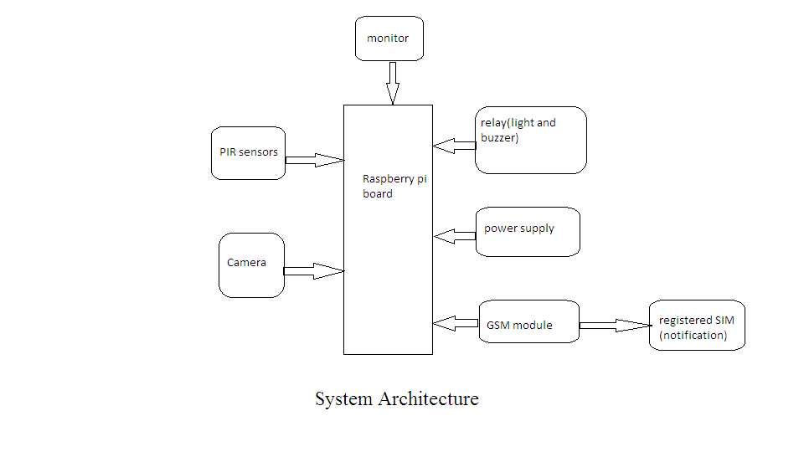

**REFLECTION NOTES**

**Technical outcomes of Internship**:

* Industrial exposure
* Basic knowledge of IOT
* Practical knowledge of various components and processes
* Learnt the design of components depending on the requirements of the input and outputs
* Understanding the industrial standard used in designing
* Programming the IC in embedded C language and burning the program and checking the output on the hardwares connected.

**Non-technical outcomes of Internship:**

* Time management
* Resource utilization skills
* Professional Communication skills
* How to approach the senior guides and other employees of the company
* Discipline in terms of making reports as well as submitting any proposals to higher authorities
* Company etiquettes
* Email etiquette

**CONCLUSION**

This internship helped us to improve our basic knowledge in the fields of electronics and in the field of IOT systems. We were very well guided and mentored by our guides in all our difficulties during the internship. We learnt different procedures involved in building a device or any equipment. As we worked on IOT and python we had to professionally carry out the designing and developing process in the appropriate step by step manner.

We also learnt how to work in a team . How to deal the issues in a professional manner . This internship helped us grow personally as a professionals . We found it very helpful in developing soft skills .